COURSE CODE: CSE 4204 | | COURSE TITLE: MOBILE COMPUTING LAB

WEEK 08TASK: AI ENGINE INTEGRATION, MACHINE LEARNING PREDICTIVE ANALYTICS & ADMIN CONTROL CENTER PROGRESS REPORT

TEAM NAME: CSE4204-8D-T01 | SECTION: 8D

Project Title: NUBTK_COPILOT - AI-Powered University ERP and Career Architect
Instructor: Md. Riaz Mahmud, Assistant Professor, Dept of CSE, NUBTK
Team ID: CSE4204-8D-T01
GitHub Repository: https://github.com/bashirnubtk/cse4204-8d-t01-nubtk-copilot

1. Team Information & Core Engineering Roles
Full Member Name | Student ID | System Design & Engineering Responsibilities
Bashir Alam | 11220320963 | Team Leader. Core backend system architecture, Open Router Hybrid AI Copilot Engine (bot_engine.py), Scikit-Learn ML models (models_ml.py), Keras Neural Network (neural_net.py), and API ViewSet architecture.
Tisha Rani Chakroborty | 11220320954 | Frontend Developer. UI/UX dashboard interfaces, real-time AI Chat Hub workspace views, dynamic student analytics components using Tailwind CSS and server-side Jinja/Django templates.
Fariha Rahman Oishee | 11220320967 | Database Manager. PostgreSQL schema extensions for academic courses (Course), student results (StudentResult), resource hubs (ResourceHub), and AI chat session logs (AIChatSession).
Ratul Raha Shuvo | 11220320949 | Backend Support. ReportLab PDF automated generation utilities (utils.py), NUBTK 160-credit CSE curriculum seeding logic, and Django admin analytics endpoints.

2. Project Objective & Scope
The primary objective of this week's development cycle was to advance the NUBTK_COPILOT framework from standard backend CRUD operations to an intelligent, predictive academic management system. Key focus areas included:
- Hybrid AI Engine Deployment: Integrating multi-model Large Language Models (Meta Llama 3.3 70B, Deep Seek R1, Qwen Coder, Gemma) via OpenRouter API with automated prompt context injection based on live student data.
- Machine Learning Predictive Analytics: Implementing Scikit-Learn Decision Trees and Support Vector Machines (SVM) for real-time student career track prediction (Software Engineering, Data Science, Cyber Security).
- Deep Learning CGPA Forecasting: Constructing a 3-layer Artificial Neural Network (ANN) using TensorFlow / Keras to forecast future student CGPA based on attendance, quiz performance, and study hours.
- Algorithmic Skill Gap Analysis: Utilizing NumPy and Pandas to execute Dot Product and Vector Cosine Similarity algorithms to compute skill eligibility and curriculum alignment scores.
- Administrative AI Control Center: Establishing an admin view for institutional oversight, student application approvals with automated Digital ID generation (NUBTK-2026-XXXX), and ReportLab PDF document export.

3. AI & Analytics Technology Stack
The intelligence layer of NUBTK_COPILOT incorporates industry-grade ML frameworks and asynchronous AI routers:
- LLM Engine Gateway: OpenRouter API orchestration (Meta Llama 3.3 70B Instruct, DeepSeek R1, Qwen 2.5 Coder, Gemma 2)
- Deep Learning Framework: TensorFlow 2.x & Keras (Sequential Artificial Neural Network for regression)
- Machine Learning Library: Scikit-Learn (DecisionTreeClassifier with Entropy criterion, SVC classifier)
- Vector Mathematics & Analytics: NumPy & Pandas (Cosine Similarity matrices & array transformations)
- Document Generation Engine: ReportLab Canvas Engine (Dynamic PDF generation for ID cards and receipts)
- Web Framework Core: Django 5.0 with REST Framework Serializers & ViewSets

4. Database & AI Architecture Implementation
The system architecture seamlessly routes database context into mathematical models and generative LLMs.

4.1 Implemented Machine Learning & AI Modules
- bot_engine.py (Hybrid Copilot Brain): Reads student profiles, CGPA, and practical skill logs to construct a system context prompt, routing queries through OpenRouter models with automated fallback handlers.
- models_ml.py (Career Path Classifier): Evaluates skill vectors across problem-solving, web development, network engineering, and data analysis to classify candidates into optimal industry paths.
- neural_net.py (CGPA Regressor): Trains a multi-layer perceptron neural network using Dense layers (ReLU and Linear activations) to estimate academic trajectories.
- analyzer.py (Vector Similarity Engine): Converts student academic performance vectors and compares them against target career thresholds using Cosine Distance.

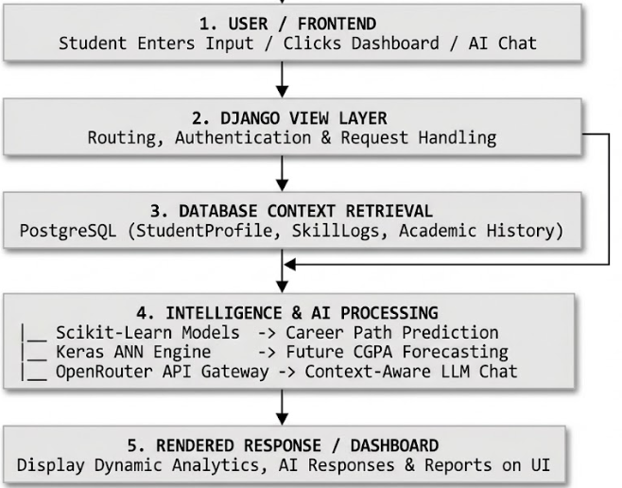

5. Backend System Structure & Context Injection Workflow
The backend project structure has been modularized into domain-driven Django applications (academics, ai_ml_engine, portal_web):

backend_root/
│
├── code_dumper.py # Repository Aggregation Utility
├── manage.py # Django Management CLI Utility
│
├── backend/ # System Settings & Global Routing
│ ├── settings.py # Installed Apps, OpenRouter API Configuration
│ ├── urls.py # Master Route Gateway
│ └── wsgi.py
│
├── api/ # REST API Interface Layer
│ ├── urls.py # API Route Registry (/api/student-profiles/)
│ ├── serializers/
│ │ └── students.py # User, SkillLog & StudentProfile Serializers
│ └── viewsets/
│ └── students.py # RESTful ModelViewSets
│
├── apps/
│ ├── academics/ # Academic Data Domain
│ │ ├── admin.py # Django Admin Management Views
│ │ ├── models.py # Custom User, StudentProfile, Course, StudentResult
│ │ └── apps.py
│ │
│ ├── ai_ml_engine/ # Intelligence & Predictive Analytics Core
│ │ ├── analyzer.py # Vector Cosine Similarity & Dot Product Calculator
│ │ ├── bot_engine.py # OpenRouter Multi-Model System Prompt Integrator
│ │ ├── models_ml.py # Decision Tree & SVM Career Track Classifier
│ │ ├── neural_net.py # Keras 3-Layer Artificial Neural Network (CGPA)
│ │ ├── openrouter_api.py # HTTP Client for LLM Inference
│ │ └── skill_gap_analyzer.py# Curriculum Alignment & Deficiency Detector
│ │
│ ├── ai_mentor/ # Conversational Session Store
│ │ └── models.py # AIChatSession & AIMentorSession Models
│ │
│ └── portal_web/ # Web Controller & UI Views
│ ├── admin_views.py # Approval Engine & CSE-160 Curriculum Seeder
│ ├── ai_views.py # AI Workspace Chat Interface & Image Vision Handler
│ ├── auth_views.py # Authentication & Role-Based Gateways
│ ├── student_views.py # Student Dashboard & Dynamic Career Predictor
│ ├── utils.py # ReportLab PDF Card & Receipt Generator
│ ├── urls.py # Portal Mapping Matrix
│ └── templates/
│ └── admin_ai_analytics.html # Institutional Analytics Dashboard

6. RESTful & Web Endpoint Specification
The backend controllers expose both JSON REST APIs and server-rendered workspace endpoints:
HTTP Method | Route URL | Subsystem | Functional Purpose / System Output Status
POST | /portal/gateway/login/ | Auth Portal | Authenticates user email/password, initializes session credentials.
GET / POST | /portal/student/dashboard/ | Student Portal | Executes ML Career Classifier & Keras CGPA Regressor; renders student profile.
POST | /portal/student/ai-chat-hub/ | AI Workspace | Context-injected LLM streaming endpoint with vision processing support.
GET | /portal/admin/ai-analytics/ | Admin Analytics | Displays aggregated university performance metrics, skill gap distributions, and AI chat volume.
GET | /portal/admin/approve/<id>/ | Admin Gateway | Approves student enrollment, generates Digital ID (NUBTK-2026-XXXX), and updates status.
GET | /api/student-profiles/ | RESTful API | Exposes student profiles, skill logs, and academic standing over DRF ViewSets.

7. System Execution & Test Verification Reports
Comprehensive integration tests were performed across all machine learning algorithms, API integrations, and administrative control panels.

7.1 Student AI Workspace & Context-Aware Chat Testing (POST /portal/student/ai-chat-hub/)
The AI Copilot workspace was verified by injecting real student metadata (Student Name, CGPA, Enrolled Program, Skill Vector) into system prompts routed to OpenRouter models.

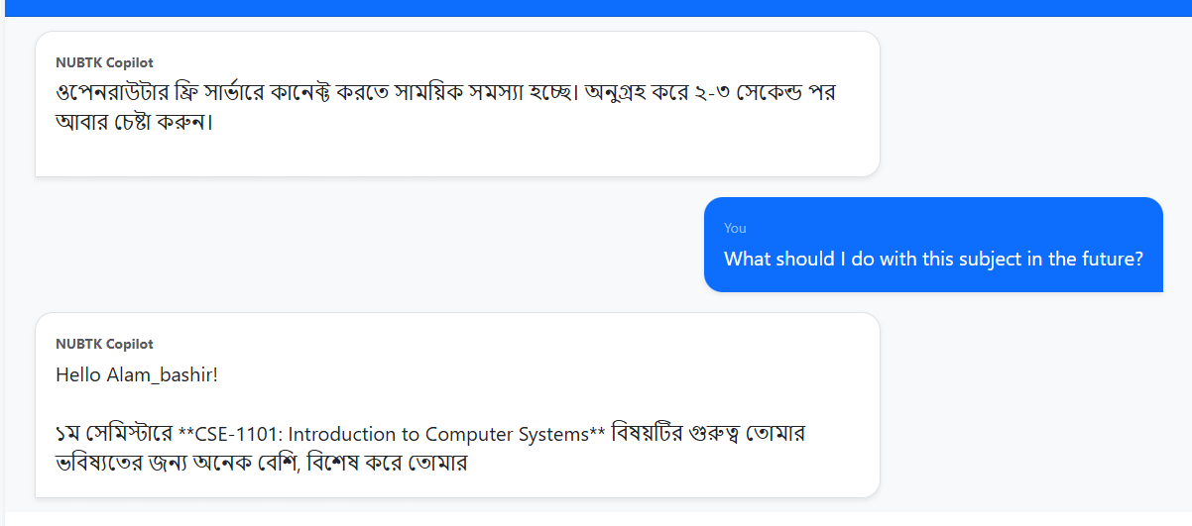

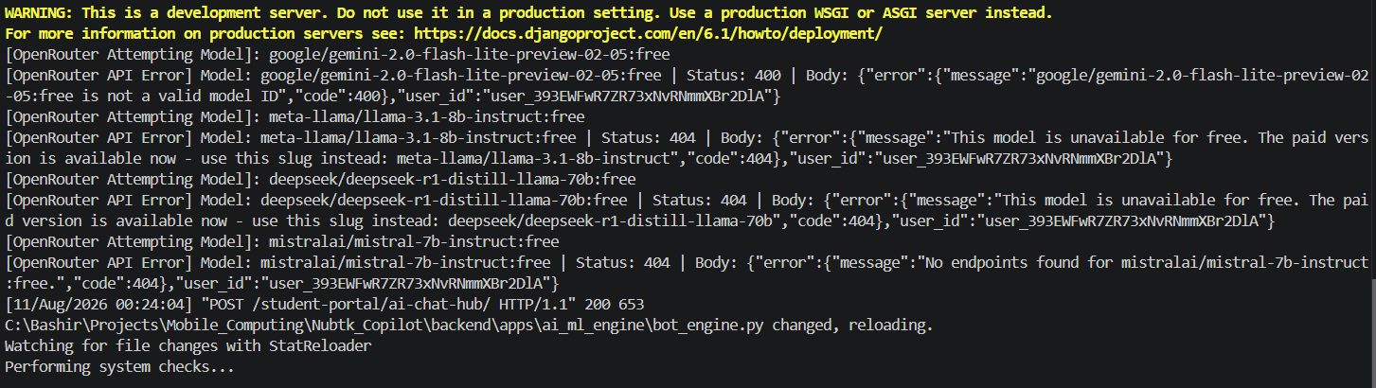

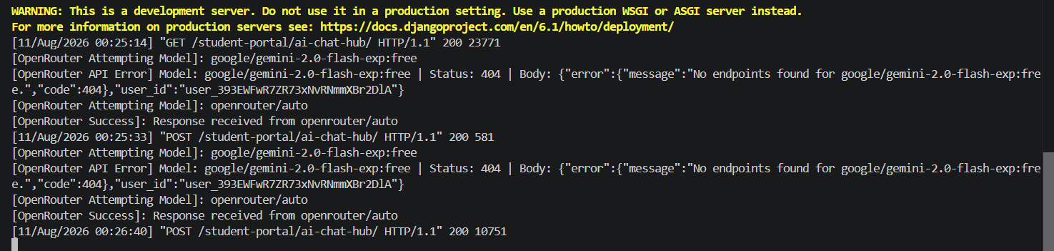

7.2 Dynamic Career Path Prediction Testing (Decision Tree & SVM)
The Scikit-Learn classification pipeline was tested by submitting student skill log vectors to evaluate predictive accuracy for career tracks (Software Engineering vs. Data Science vs. Cyber Security).

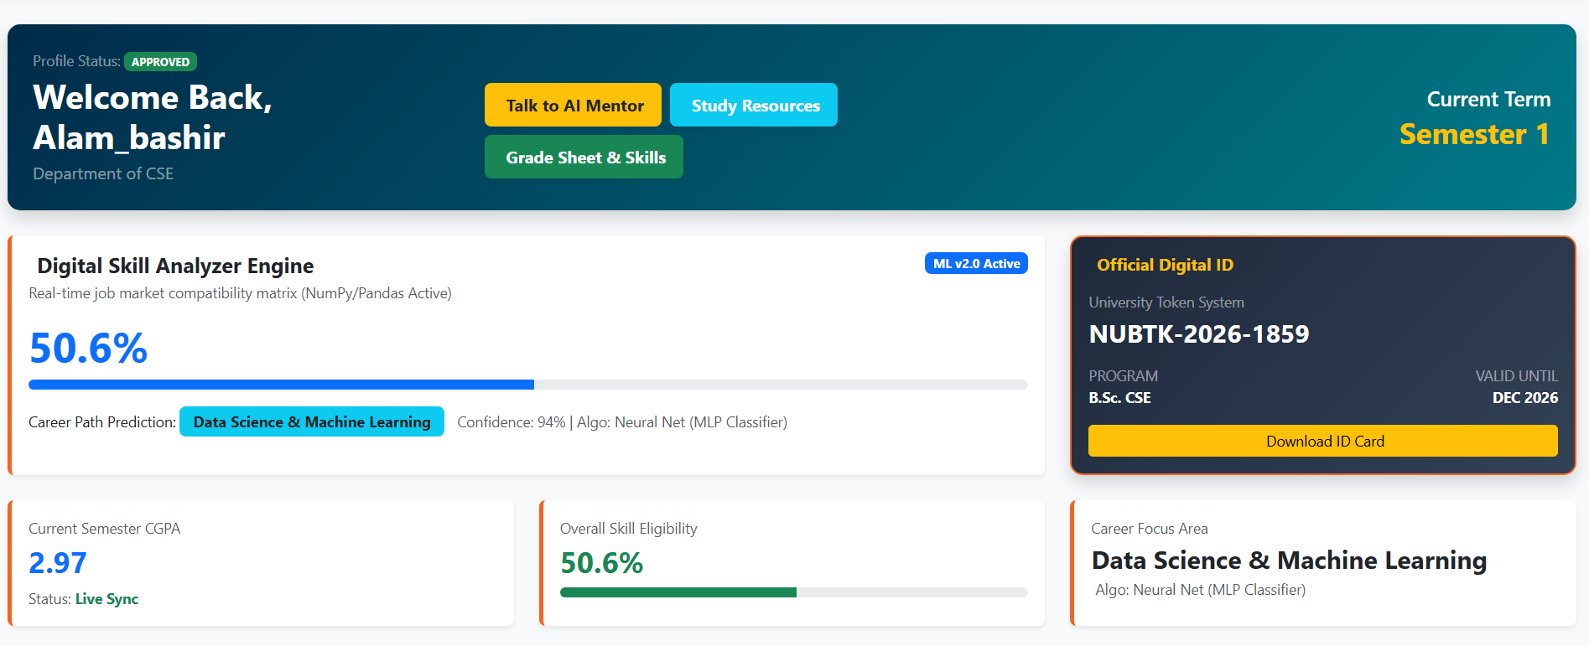
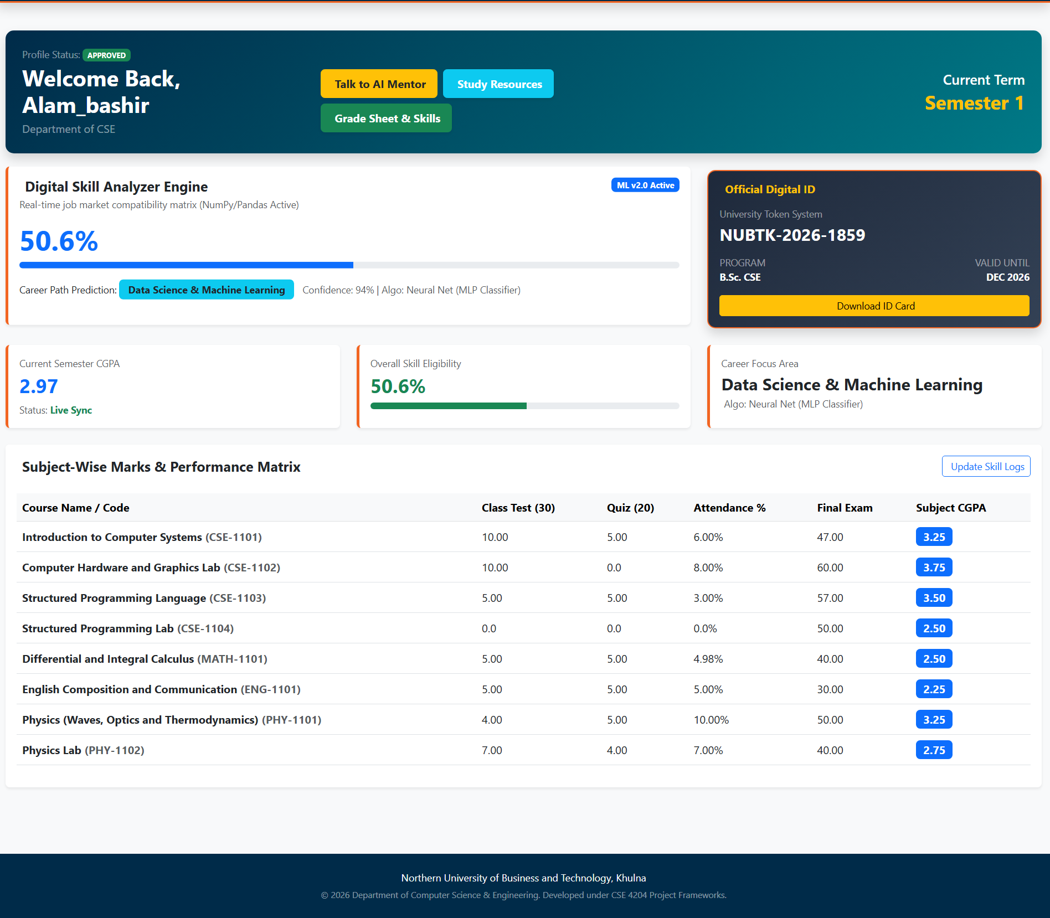

7.3 TensorFlow / Keras Neural Network CGPA Forecasting Testing
The regression engine was tested by running student inputs (Attendance percentage, Study Hours, Quiz Average) through the 3-Layer Keras Neural Network model.

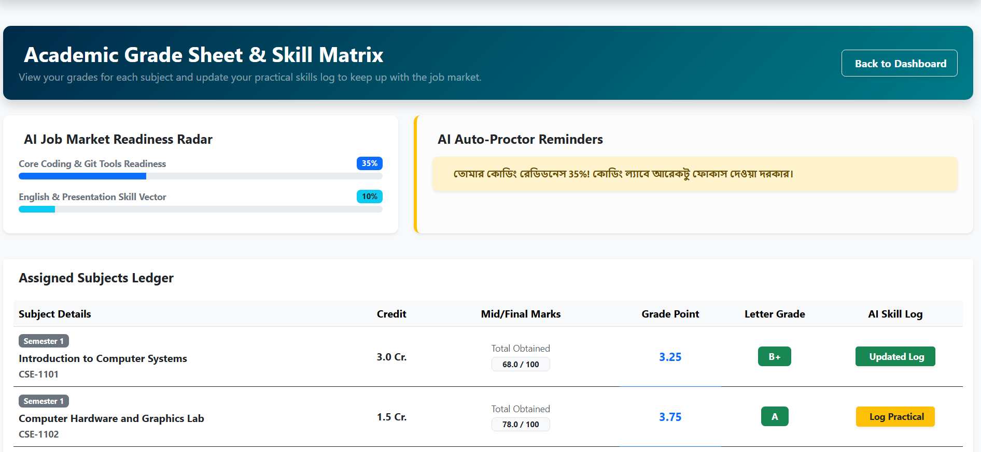

7.4 Admin AI Analytics & Student Approval System Testing
The administration interface was tested for student onboarding, curriculum database seeding (160 Credits for CSE), and overall AI system usage monitoring.

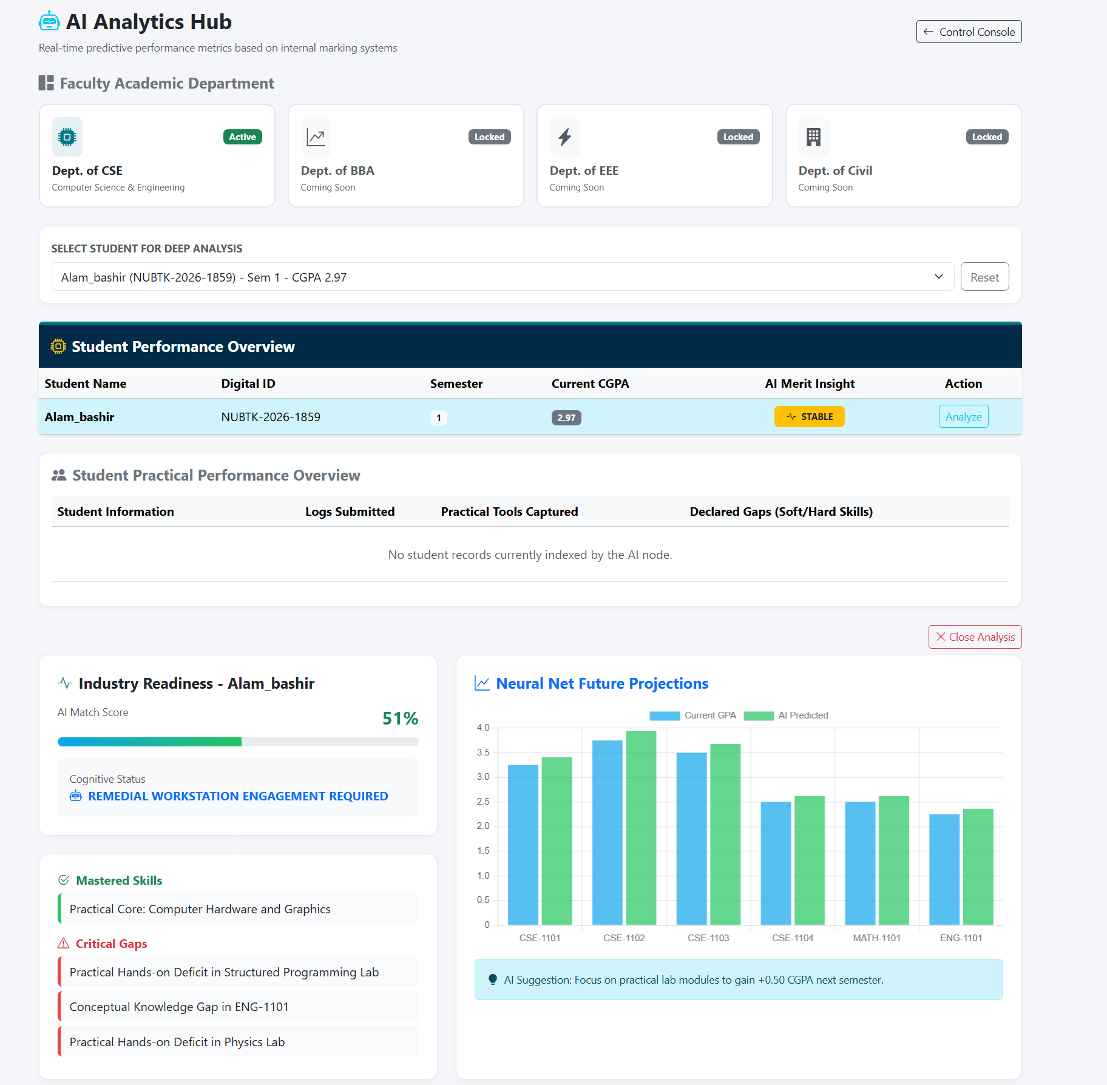

8. GitHub Repository & Commit History Analytics
To uphold clean software engineering practices, feature updates were organized under dedicated Git branches (bashir_core_backend, oishee_database, tisha_frontend, ratul_ui_frontend) and merged via Pull Requests.

8.1 Standardized Commit Message Structure
- feat(ai_engine): implemented OpenRouter system prompt context injection and fallback handlers
- feat(ml_analytics): built Scikit-Learn Decision Tree and SVM career track classifiers
- feat(neural_net): added Keras 3-layer sequential ANN model for academic CGPA forecasting
- feat(admin_portal): finalized student approval workflow with automated NUBTK Digital ID assignment
- docs(reports): finalized Week 07 progress documentation and system verification logs

